About the Project:
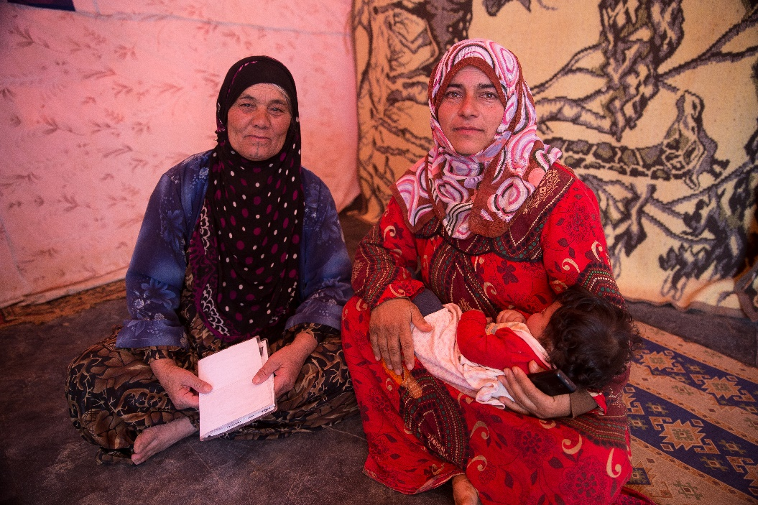
Women Rise: A Gender-based Violence PSS Framework and Resource Package meets a widely acknowledged gap in guidance for gender-based violence (GBV) practitioners to facilitate group support sessions with women at risk or women survivors of GBV. Violence against women and girls in humanitarian settings is widely acknowledged and increasingly documented by researchers, practitioners, and human rights observers. Research suggests that women who have experienced GBV endure enormous psychological suffering because of violence.,,
While there has been increasing and welcome recognition of Mental Health and Psychosocial Support (MHPSS) as a critical area of work within the humanitarian sector, much confusion remains as to the role psychosocial support activities play in protection programming and more specifically GBV prevention and response. Existing guidance does not center women in PSS approaches. GBV actors therefore continue to lack a framework and practical resources to implement psychosocial support activities for displaced women and girls, beyond individualized GBV case management.
To address this gap, IRC is developing and piloting a global psychosocial support resource package organizations providing GBV services in emergency and protracted displacement settings. The resource package will include:
- An overarching intervention framework for PSS interventions in GBV prevention and Response
- Guidance on best practices in PSS programming for GBV actors
- A specific group psychosocial support curriculum at level 3 (focused, non-specialized support) of the MHPSS pyramid
- Core Competency training materials for PSS facilitators
- Guidance for development of recreational and life-skills activities
- Other Key Resources
The package is currently under development in close consultation with IRC’s technical advisors, front-line staff, and an advisory group of MHPSS and GBV technical experts and field staff across multiple agencies.
Resource development and piloting will take place throughout 2019 and 2020 with final revision and reviews taking place in 2020. The official launch of the Women Rise Resource Package will take place in late 2020. Once complete, materials and training packages will be translated into French and Arabic, and all content will be published online through the GBV Responders website.
For more information and/or to get involved with the development of the Women Rise resource package, please contact Gretchen Emick (Gretchen.emick@rescue.org)

Campbell R., Dworkin E., & Cabral G. (2009) An ecological model of the impact of sexual assault on women's mental health. Trauma Violence Abuse 10: 225-246
WHO (2009). Mental Health Aspects of Women's Reproductive Health: A Global Review of the Literature. Geneva, World Health Organization.
Chen L.P, Murad M.H., Paras M.L., Colbenson K.M., Sattler A.L., Goranson E.N., Elamin M.B., Seime R.J., Shinozaki G., Zirakzadeh A. (2010). Sexual Abuse and Lifetime Diagnosis of Psychiatric Disorders: Systematic Review and Meta Mayo Clin Proc. 85(7):618-629.

